Report of Poverty Probability:
The data set is about poverty probability by country which shows the poverty percentage in different country. The data is very dirty which contains lots of null values which needs to be focused and filled with relevant values or remove those columns or rows. Many column are those which makes no sense like female, married, is_urban, literacy etc which needs to be corrected through various methods such as melting etc. There are some irrelevant columns which can be removed so those column cannot occupy unnecessary space. Then the plotting libraries and techniques can be used to explain relationship between poverty probability and different important features like country, age, marital status, educational level etc, the distributions of different features. Following are the plots bellow will help to tell the story about the data set and discuss much more about data set:

Distribution Plot or Histogram:
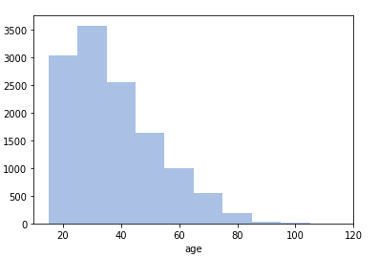
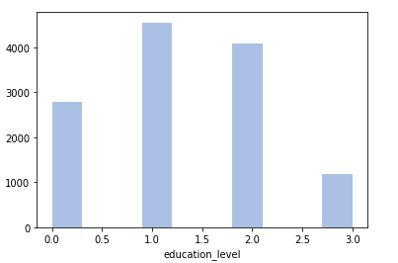

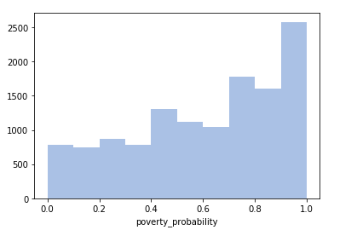
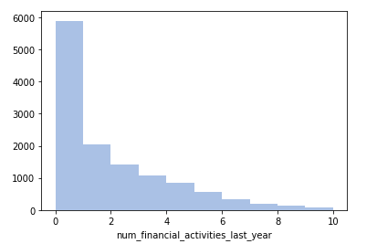

The above distribution plots shows the distribution of age, poverty probability, education level and number of financial activities through out the whole data set.
In x-axis there are different columns and in y-axis the number of occurrence in complete data set. For example in first plot of age, people between 20 and 30 years of age occurred near 3000, 30-40 years of age occurred near 3500 times, 40-50 years of age occurred nearly 2500 times and so on. In second plot the education level distribution is shown that people in the country with 0 level are near to 2900, people in the country with level 1 are near to 5000, with level 2 are near to 4000 and with level 3 are near to 4000. In 3rd graph the poverty probability shows that the people in data sets are mostly poor. 4th graph shows that less number of financial activities are performed last year.

Correlation of Variables Plot:
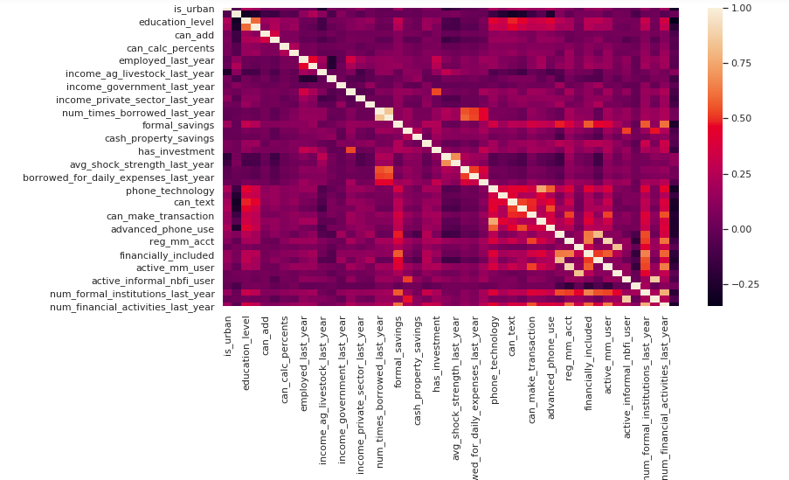

The correlation coefficient is a statistical measure that calculates the strength of the relationship between the relative movements of two variables. The values range between -1.0 and 1.0. A correlation of -1.0 shows a perfect negative correlation, while a correlation of 1.0 shows a perfect positive correlation. A correlation of 0.0 shows no relationship between the movement of the two variables. The above graph shows the correlation coefficient of between all the columns present in the data set. Lightest color i.e white shows the negative correlation, the dark most color i.e black represents the positive correlation and purple color represents no correlation.

Scatter Plots:

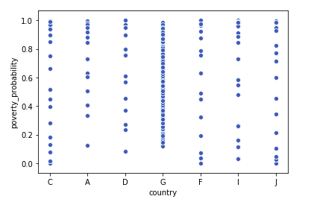
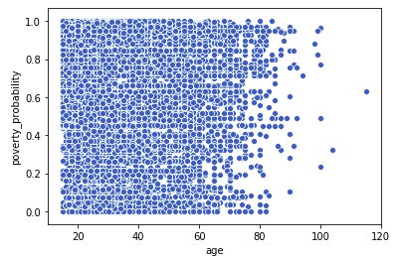

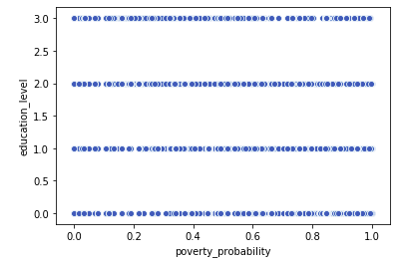
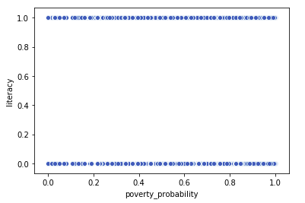

Above scatter plots represents relationship between two variables. All these plots are showing the relationship of poverty probability with different variables like country, age of people, education level and literacy. 1st plot shows that the country named G has strong poverty probability which means that country G have mostly poor people. 2nd graph shows that people under 80 has strong poverty probability.

Further Challenges:
The provided data set is very dirty which should be cleaned and make it tidy using various cleaning methods to use it further to make predictions and achieve high accuracy while making predictions. Firstly some columns need to be melted and so that the column can make some sense to machine learning model and the accuracy of model do not suffer. Secondly those columns need to be removed that are irrelevant according to context. Thirdly the categorical attributes need to be encoded for making predictions on it.

Python Code:

#importing useful libraries
import os
import numpy as np
import pandas as pd
import matplotlib.pyplot as plt
import seaborn as sns

#loading datasets
train_values = pd.read_csv('train_values_wJZrCmI.csv')
train_labels = pd.read_csv('train_labels.csv')
display(train_values)
display(train_labels)

# Merging two datasets that is train values and train labels
merged = pd.merge(train_values,train_labels, how = 'inner', right_on = "row_id", left_on = "row_id")
display(merged)

#setting row_id as index
merged.set_index('row_id',inplace=True)
display(merged)

#showing description of the dataset
merged.describe()

#showing description of boolean and object types of datasets
merged.describe(include=['object','bool'])

#Showing the info of the merged dataset of poverty probablity
merged.info()

#showing the number of null values
merged.isnull().sum()

#filling na values in education_level with 0
display(merged['education_level'].head(20))
merged['education_level'].fillna(0,inplace=True)
merged['education_level'].isnull().sum()

#handelling column share_hh_income_provided and displaying
display(merged['share_hh_income_provided'].head(19))
display(merged['share_hh_income_provided'].tail(19))
display(merged['share_hh_income_provided'][140:160])

#filling na values with the median of the concerned column
merged['share_hh_income_provided'].fillna(merged['share_hh_income_provided'].median(),inplace = True)
merged['share_hh_income_provided'].isnull().sum()

#dropping tables unnecessary tables
merged.drop('bank_interest_rate', axis=1, inplace=True)
merged.drop('mm_interest_rate', axis=1, inplace=True)
merged.drop('mfi_interest_rate', axis=1, inplace=True)
merged.drop('other_fsp_interest_rate', axis=1, inplace=True)

#showing info after filling na values
merged.info()

#changing the datatype of column age
merged['age']=merged['age'].astype(int)
merged['age']

#converting column female to gender
merged['female'][merged['female']==True]='female'
merged['female'][merged['female']==False]='male'
merged.rename(columns={'female': 'gender'},inplace=True)
display(merged)

#converting column female to married to marital_status
merged['married'][merged['married']==False]='single'
merged['married'][merged['married']==True]='married'
merged.rename(columns={'married': 'marital_status'},inplace=True)
display(merged)

#Plotting a distribution plot
sns.distplot(merged['age'],bins=10,kde=False)
sns.distplot(merged['education_level'],bins=10,kde=False)
sns.distplot(merged['num_financial_activities_last_year'],bins=10,kde=False)
sns.distplot(merged['poverty_probability'],bins=10,kde=False)

#calculating correlatio coefficient
corr = merged.corr()
corr

#plotting heatmap of correlation coefficient
sns.set(rc={'figure.figsize':(11.7,6.27)})
sns.heatmap(corr)

# plotting scatter plot
sns.scatterplot(x=merged['age'],y=merged['poverty_probability'])
sns.scatterplot(y=merged['education_level'],x=merged['poverty_probability'])
sns.scatterplot(x=merged['country'],y=merged['poverty_probability'])
sns.scatterplot(y=merged['literacy'],x=merged['poverty_probability'])

